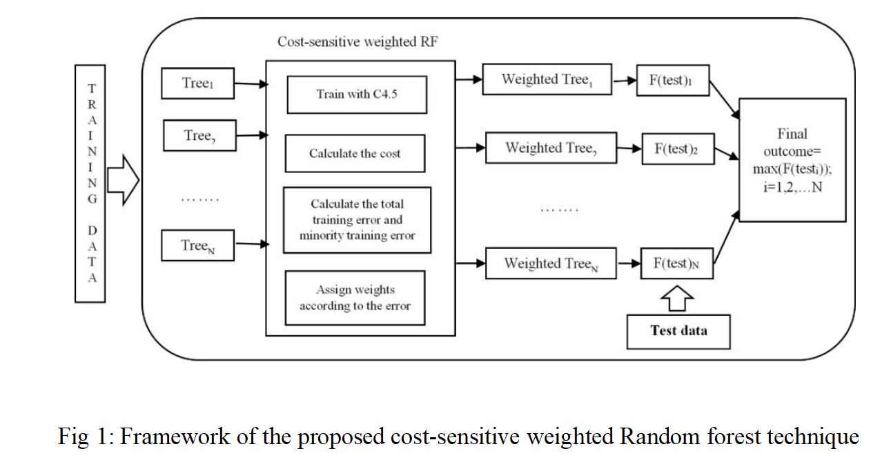

Upload Credit Card Dataset

Generate Train&Test Model

Run Random Forest Algorithm

Detect Fraud From Test Data

Clean & Fraud Transaction Detection Graph

**USECASE DIAGRAM**

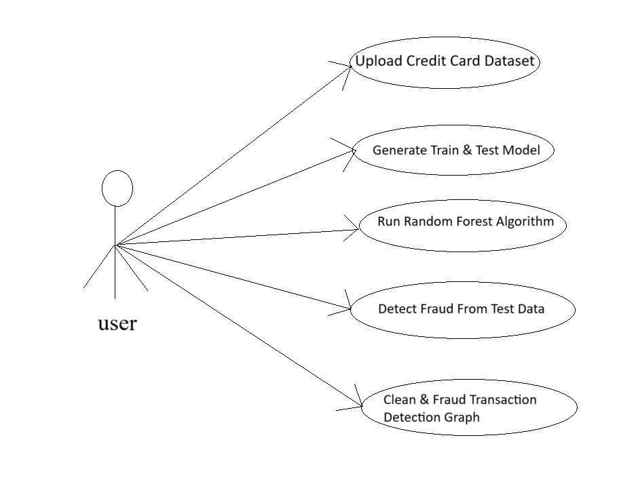

**DATA FLOW DIAGRAM**

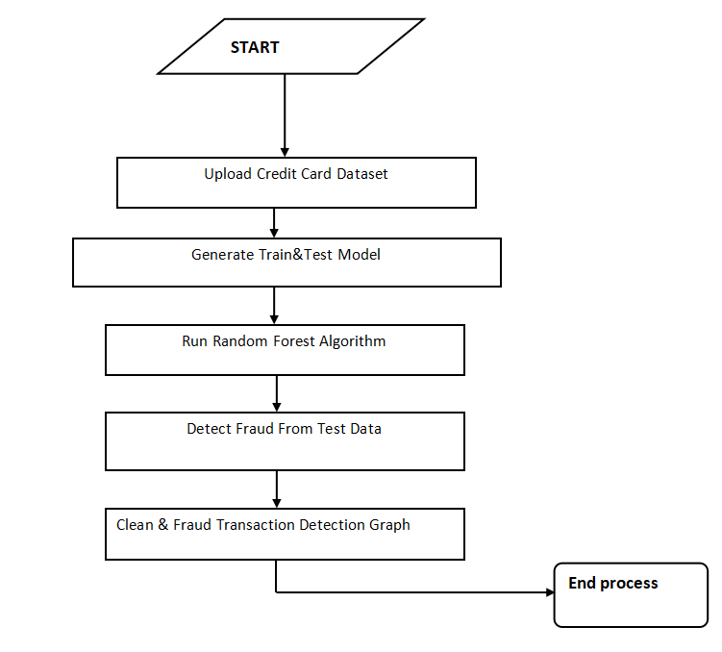

from tkinter import messagebox

from tkinter import *

from tkinter import simpledialog

import tkinter

from tkinter import filedialog

import matplotlib.pyplot as plt

import numpy as np

from tkinter.filedialog import askopenfilename

import numpy as np

import pandas as pd

from sklearn import *

from sklearn.model_selection import train_test_split

from sklearn.metrics import accuracy_score

from sklearn.metrics import classification_report

from sklearn.ensemble import RandomForestClassifier

from PIL import ImageTk,Image

#from sklearn.tree import export_graphviz

#from IPython import display

main = tkinter.Tk()

main.title("Efficient Payment Fraud Detection with Meta Learning Classifier in a Cost-Sensitive Framework")

main.geometry("1300x1200")

global filename

global cls

global X, Y, X_train, X_test, y_train, y_test

global random_acc # all global variables names define in above lines

global clean

global attack

global total

def traintest(train): #method to generate test and train data from dataset

X = train.values[:, 0:29]

Y = train.values[:, 30]

print(X)

print(Y)

X_train, X_test, y_train, y_test = train_test_split(

X, Y, test_size = 0.3, random_state = 0)

return X, Y, X_train, X_test, y_train, y_test

def generateModel(): #method to read dataset values which contains all five features data

global X, Y, X_train, X_test, y_train, y_test

train = pd.read_csv(filename)

X, Y, X_train, X_test, y_train, y_test = traintest(train)

text.insert(END,"Train & Test Model Generated\n\n")

text.insert(END,"Total Dataset Size : "+str(len(train))+"\n")

text.insert(END,"Split Training Size : "+str(len(X_train))+"\n")

text.insert(END,"Split Test Size : "+str(len(X_test))+"\n")

def upload(): #function to upload tweeter profile

global filename

filename = filedialog.askopenfilename(initialdir="dataset")

text.delete('1.0', END)

text.insert(END,filename+" loaded\n");

